**Introduction & Objectives**

The salmonid *Oncorhynchus mykiss* exhibits substantial variation in developmental life-history. Resident ‘rainbow trout’ complete the entirety of their lifecycle in freshwater systems, whereas anadromous ‘steelhead’ engage in oceanic migrations and later return to natal rivers via freshwater runs to reproduce. Variation in residency - anadromy, as well as the timing of upstream return appear to be under strong genetic control, and the ability to predict developmental life-history could serve as a unique and powerful tool in managing this species. Yet, the genetic architecture of migratory behavior is complex, warranting further validation of diagnostic markers, especially in untested localities where the relationship between genotypic state and phenotype remains unclear. Here, we characterize the genetic composition of *O. mykiss* anadromous steelhead in Oregon’s Siletz River at markers implicated in residency-anadromy (Omy - 5) and run-timing (Omy – 28) phenotypes, as well as a set of putatively neutral markers. We compare our findings to those reported in other geographic regions for anadromous *O. mykiss* with early- and late-summer run timing.

**Methods**

*O. mykiss* were sampled from June 21st, 2022 – November 4th, 2022, at Valsetz Falls in the Siletz River by Oregon Department of Fish and Wildlife (ODFW). In total, fin clips from 291 natural origin fish were sampled and preserved in 95% ethanol. Genomic DNA was extracted from preserved fin clips and used as template to genotype individuals at a panel of previously characterized single nucleotide polymorphisms (SNPs) using Genotyping-in-Thousands by sequencing (GT-seq).

In the initial panel, individuals were genotyped at 391 biallelic markers. Of these, 251 represent putatively neutral loci, 135 loci are associated with adaptive phenotypes, 4 are used in species identification (Omy_Omyclmk438-96, Omy_myclarp404-111, Oki120255-113, Ocl_gshpx-357), and 1 sex identification marker (OmyY1_2SEXY). The 135 adaptive markers were composed of 6 markers located on chromosome 5 (Omy – 5) associated with residency – anadromy, 14 markers located on chromosome 28 (Omy – 28) associated with seasonal run timing, and 115 markers associated with a multitude of other adaptive phenotypes.

We filtered individuals and markers genotyped with poor quality based on call rates and the individual fuzziness index (IFI). Individuals and markers were removed iteratively until both had call rates of at least 90% and 80%, respectively. Additionally, 35 markers were removed owing to a lack of allelic balance in heterozygous calls and/or monomorphism across all individuals. A single individual (OmyAC22SILR_0125) was heterozygous at all four of the species identification markers and was removed from the dataset. Species identification markers were removed from the filtered panel prior to analyses. Two markers of interest, one Omy-5 (OmyR40319) and one Omy-28 (Chr28_11632591) were flagged by our filtering thresholds for monomorphism but were retained for analyses.

The genotypic states and frequencies of Siletz River *O. mykiss* were compared at Omy-5 and Omy-28 markers to those previously reported for anadromous steelhead with summer run timing (Pearse et al. 2014; Dayan et al. 2023).

**Results & Conclusion**

Quality filtering resulted in a dataset composed of 290 *O. mykiss* genotyped at 349 markers. The filtered marker set contained 237 putatively neutral loci, 111 loci associated with adaptive phenotypes, and 1 sex identification marker. The 111 adaptive markers were composed of 6 Omy-5 markers associated with residency-anadromy, 14 Omy-28 markers associated with seasonal run timing, and 91 markers associated with a multitude of other adaptive phenotypes.

The genotypic frequencies of Siletz River *O. mykiss* were mismatched at Omy-5 markers relative to the expectation for anadromous steelhead (Fig. 1). Despite presumably anadromous phenotypes, Siletz steelhead harbored genotypes typically associated with residency in other river systems (Pearse et al. 2014).

Predominantly, *O. mykiss* genotypic frequencies in the Siletz River matched the expectation for summer run steelhead at Omy-28 markers (Fig. 2). At 6 of 7 markers evaluated, Siletz River *O. mykiss* with run times ranging from late June to early November harbored genotypic states associated with summer runs in the Rogue River (Dayan et al. 2023). However, one marker (Omy28_ 11658853) was mismatched relative to this expectation for summer run timing.

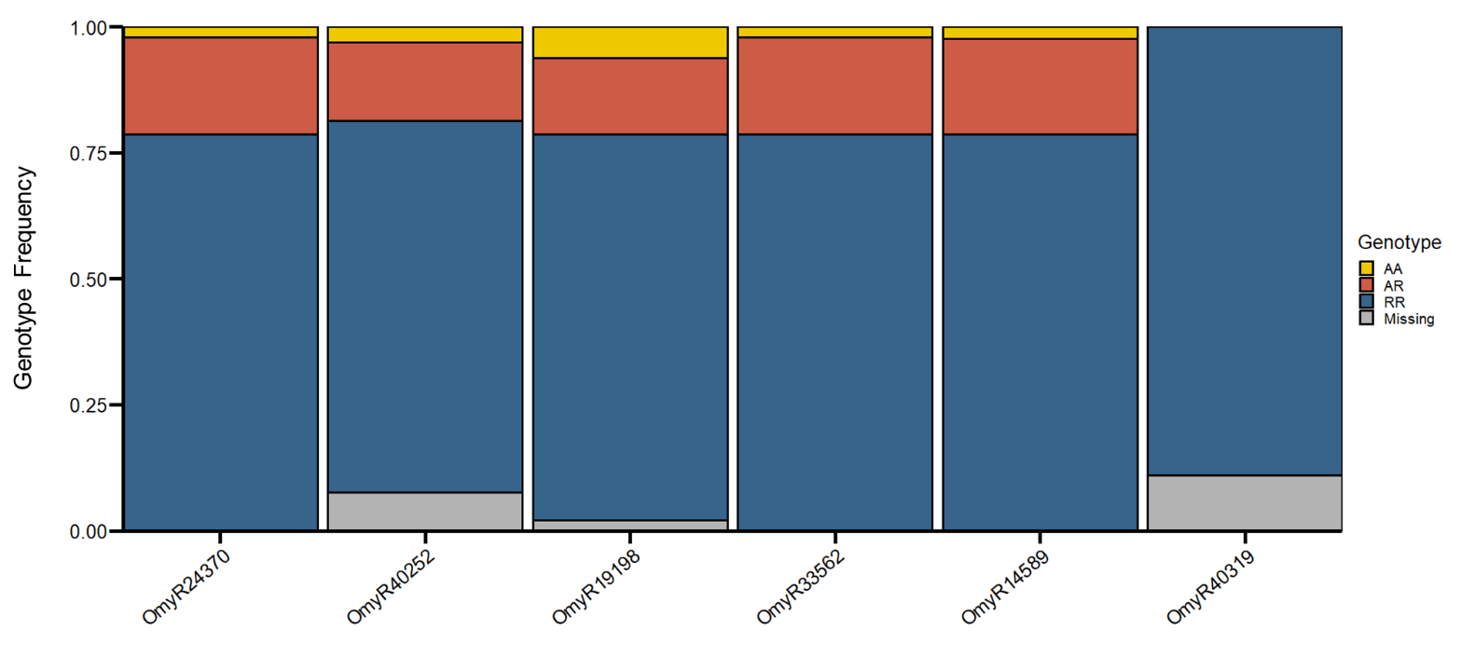

Figure 1. Genotypic frequencies of 290 natural origin anadromous Siletz River *O. mykiss* typed at 6 Omy-5 loci associated with residency - anadromy. Color corresponds to expected genotypic – phenotypic associations characterized in other river systems (Pearse et al. 2014). Blue represents homozygous resident genotypic states, red indicates heterozygous genotypic states, yellow indicates homozygous anadromous genotypic states, and grey represents uncalled missing genotypes. Markers are orientated relative to their position on chromosome 5. Mismatches between anadromous phenotypes in Siletz *O. mykiss* and expected genotypic state warrant further characterization in these markers.

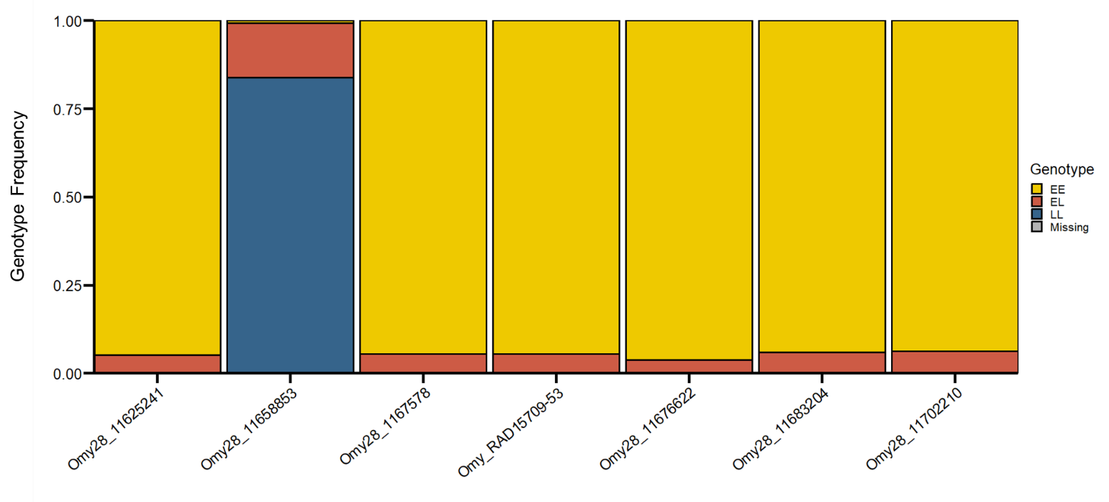

Figure 2. Genotypic frequencies of 290 natural origin Siletz River *O. mykiss* typed at 7 Omy-28 loci associated with seasonal run timing. Color corresponds to expected genotypic – phenotypic associations characterized in the Rogue River (Dayan et al. 2023). Blue represents homozygous winter run genotypic states, red indicates heterozygous genotypic states, yellow indicates homozygous summer run genotypic states, and grey represents uncalled missing genotypes. Markers are orientated relative to their position on chromosome 28. At most markers (except for Omy28_11658853), Siletz *O. mykiss* matched the expected genotypic states associated with summer run timing.

**References**

Pearse, D.E., M.R. Miller, A. Abadia-Cardoso, and J.C. Garza. 2014. Rapid parallel evolution of standing genetic variation in a single, complex, genomic region is associated with life history in steelhead/rainbow trout. Proc. R. Soc. B. 281: 20140012.

Dayan, D.I., S. Mazur, L.J. Green, A.J. Wells, M.A. Johnson, D.J. Van Dyke, P.A. Samarin, R.D. Battleson, and K.G. O’Malley. 2023. Genetic diversity within late-summer run and half-pounder steelhead (*Oncorhynchus mykiss*) in the Rogue River, Oregon. Conserv. Genet. DOI: 10.1007/s10592-023-01563-w.